Activity for “Direct Imaging of Covalent Bond Structure in
Single-Molecule Chemical Reactions”

To work with the raw data for this activity, you will first need to download the free software program “WSxM” from http://www.nanotec.es/products/wsxm/ and installing it on your computer

You will also need access to four image files, which you can access through this dropbox link: https://www.dropbox.com/sh/h53c8adywj6kkdz/AAAHeY12DDpX_3zZdzvgcJnTa?dl=0

After downloading WSxM, open the program. On Windows 7 or 8 it is better to run the program as an administrator. This does not mean to be logged on the computer as administrator, but to run the program as such. To do this, right click on the program icon and choose “Run as administrator”. It should work anyway, although not ideally.

As you open the program, your screen will show this:

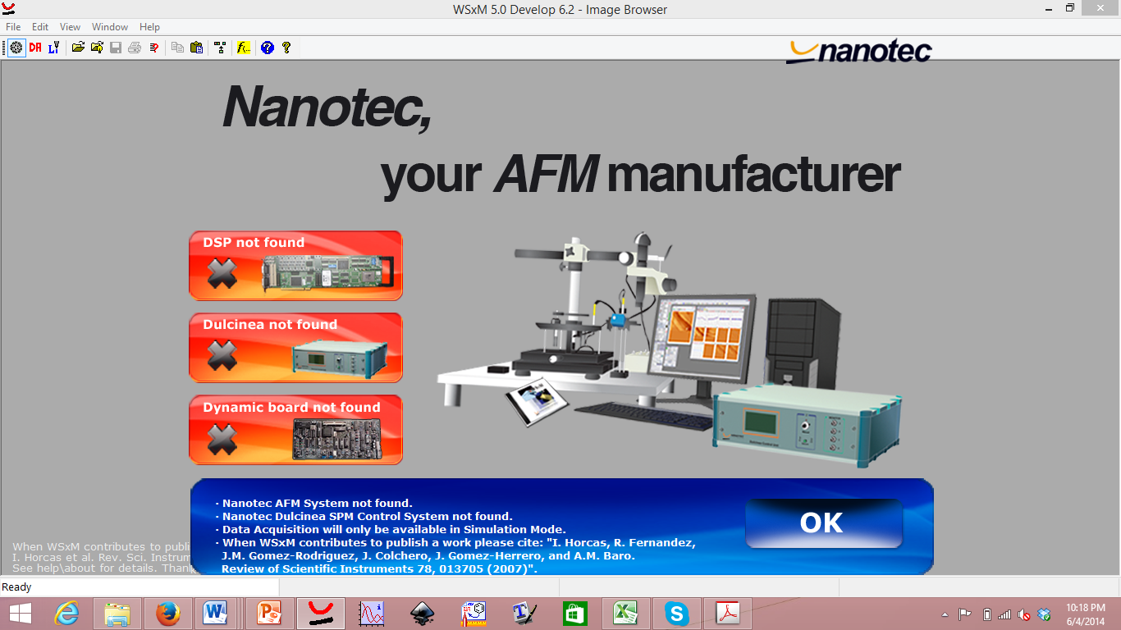

Press OK.

Go to the menu “file” and press “open”
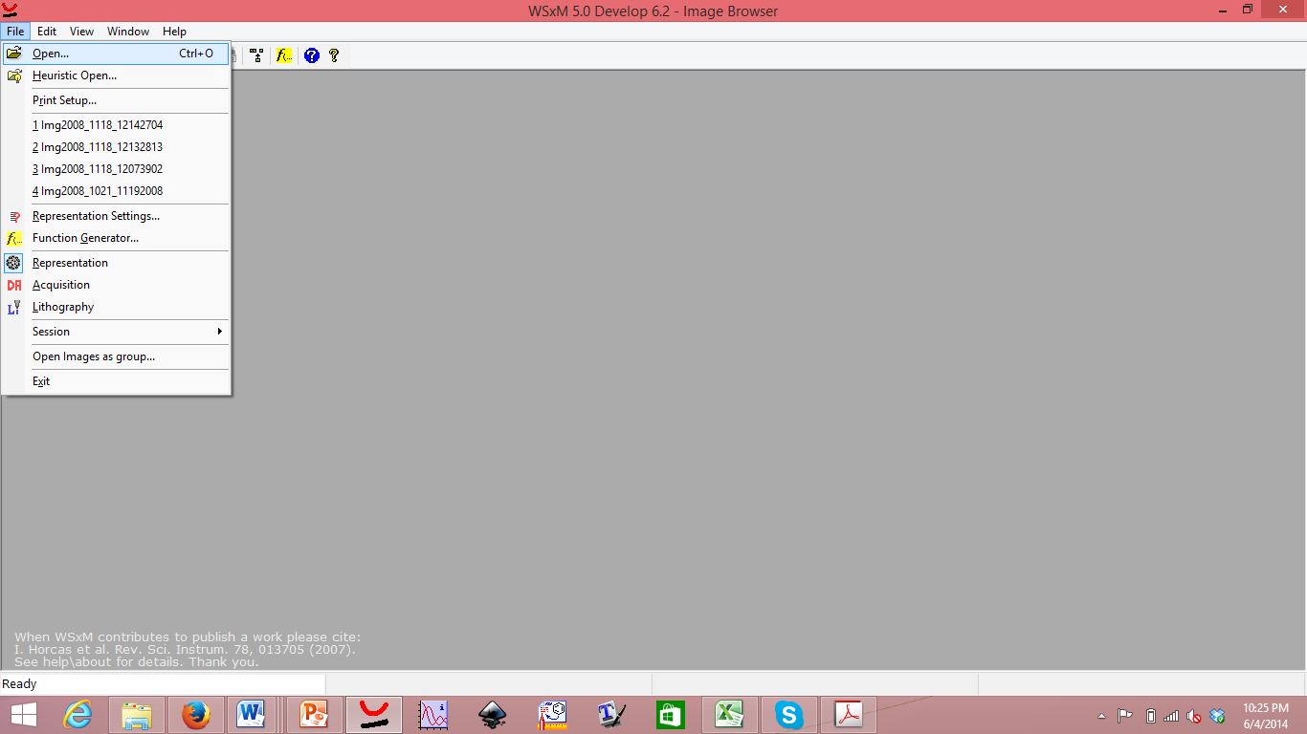

It should now look something like this:

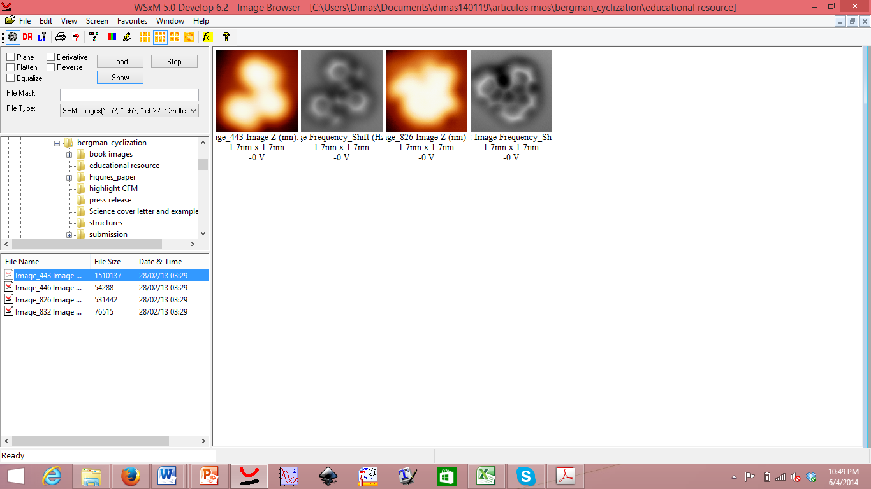

Navigate to the folder on which you have saved the images. Choose the first of the files that appear in the file name list (marked blue in the image above) and press on the button “show”.

The four images should appear in the right hand panel. Load them by choosing any image and pressing “load”. After that, minimize the “open” sub-window and you will see the image and the associated processing menu (see image below).

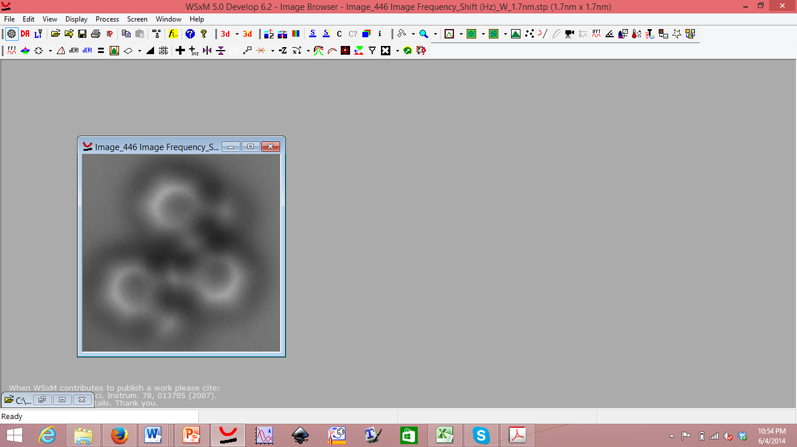

Now you can, for example, measure distances by going to the “Process” menu and choosing “Profile.”

Left-click at the desired starting point. You can use additional left-clicks if you want to add nodes to the line profile. Use a right click to end.

You can examine, for example, the width of one of the rings by making a profile across the rings (image below).

To measure the distance between two points, go to the “Process” menu and choose “Measure distance.”
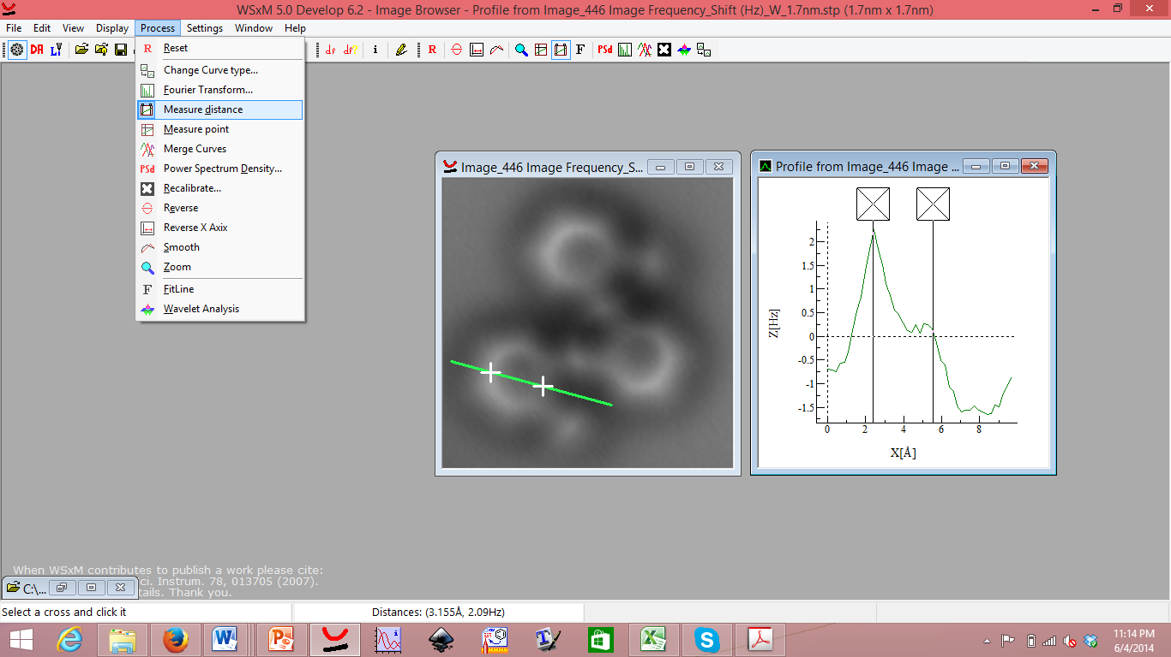

You can also measure angles by making profiles with an additional node.

In addition to measurements, you can change the appearance of the image by changing its colors (the color is arbitrary by assignment of a specific color scale to the measured quantity, whether frequency or height in the provided images). To do so go to the menu “screen” and choose “Palette settings”. There you can play with the brightness, contrast, and color scale (see below).

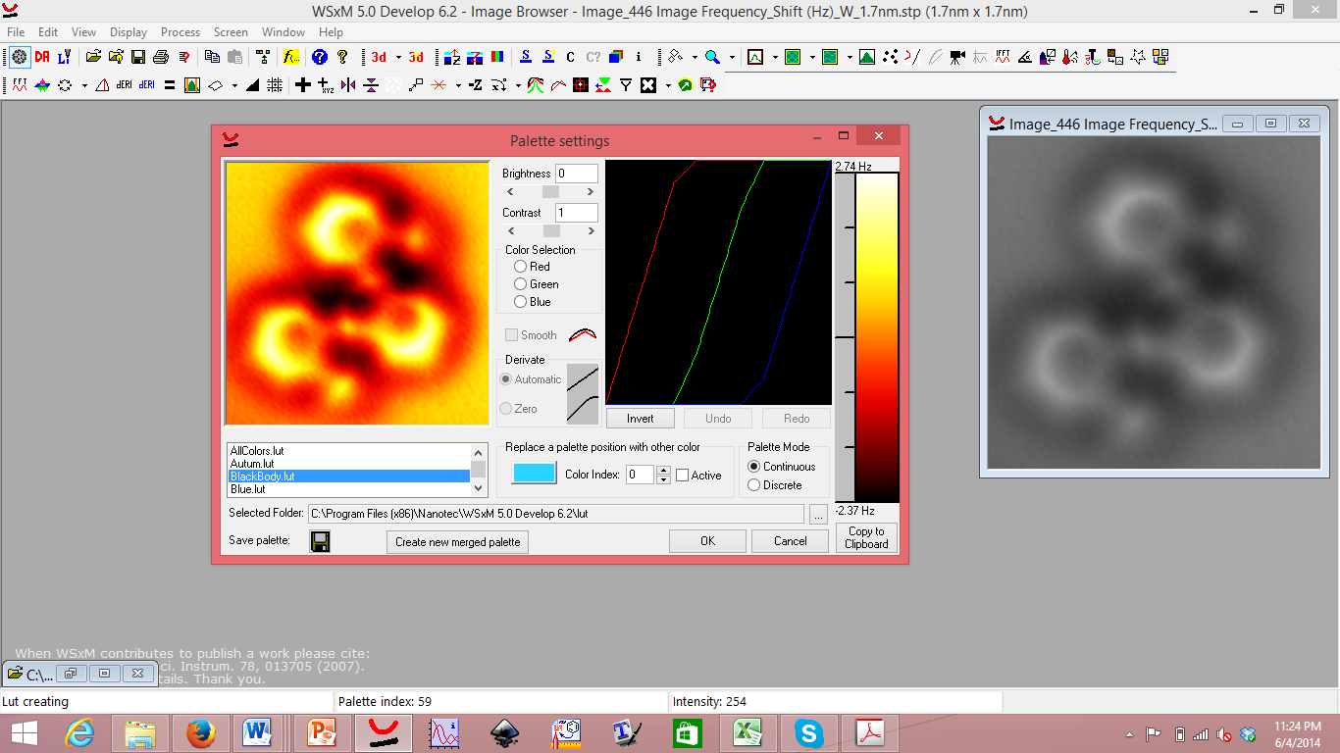

You can also display the images in 3D by going to the menu “display,” and choosing “3D.”

You can even play with the visualization parameters in “3D settings.”

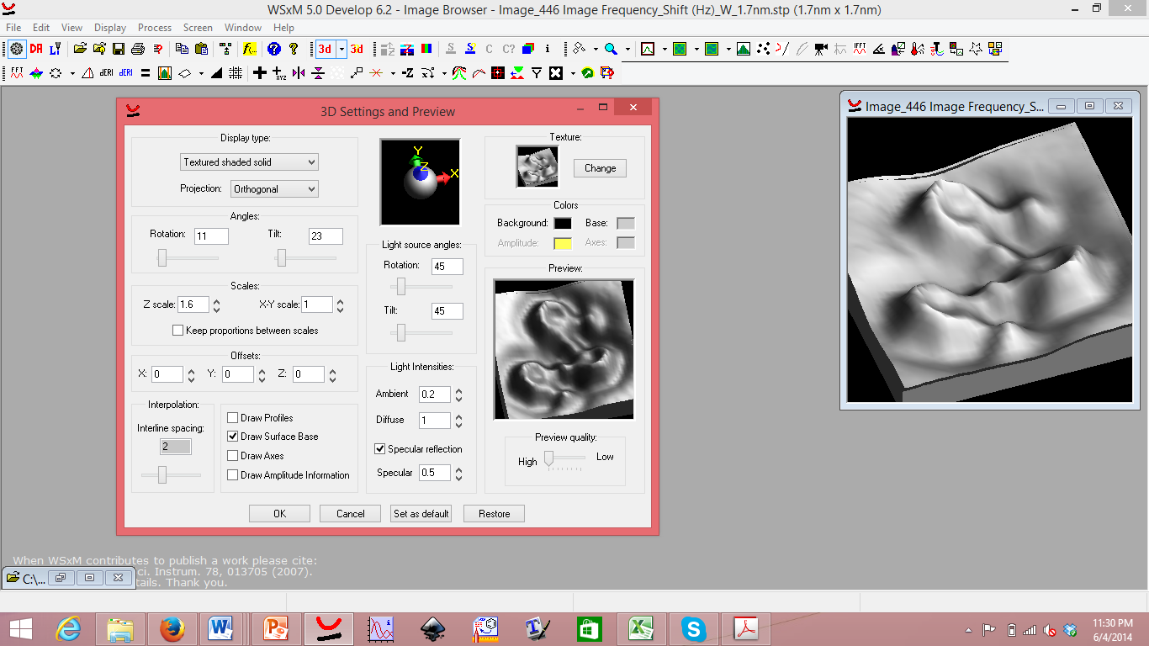

Have fun discovering more options this software offers for scientific analysis and display of images.

