There’s a new kid in town –
How native anoles avoid competition from invasive anoles

Anolis carolinensis, commonly called the Green anole (Fig. 1), is a small lizard that lives in the southeast United States. It is active during the day in vegetation close to the ground. In the 1950s, another anole lizard, the Brown anole (Anolis sagrei; Fig. 2) arrived in Florida from Cuba, probably on ships that moved between the two countries. The Brown anole became invasive, rapidly spreading its species range from South Florida into the rest of Florida as well as into parts of Georgia, Alabama, Louisiana, and Texas.

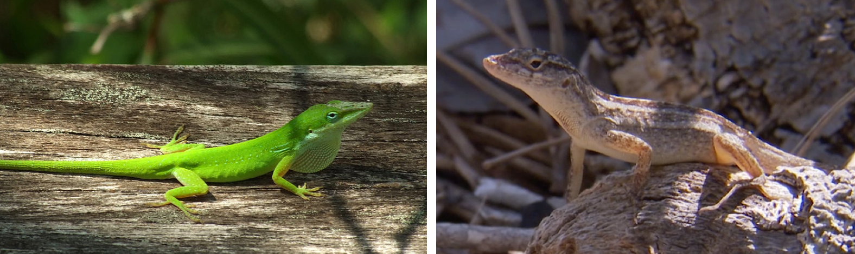
Figure 2. Anolis sagrei male, perching on a log.
Figure 1. Anolis carolinensis male on a fallen tree trunk. (Photo by Euku/Wikimedia Commons)
The Brown anole is very similar to the Green anole. Like the Green anole, it is a few inches long, eats insects, is active during the day, and favors living on the ground and low down on bushes and tree trunks. However, the Brown anole is a little bit heavier than the Green anole and also more aggressive when forming and defending territories.

Given that both species have such similar ecological niches, the question arises what effect the invasive Brown anole might have on the native Green anole.

In Cuba, for example, where close relatives of the Green anole live together with the Brown anole (i.e. both species are sympatric), the Green anoles spend most of their time higher up in the trees, probably because of competition with the more aggressive Brown anole. But how do they manage to perch high and not fall down?

Anoles are able to cling to trees, branches, and tree trunks by using special, expanded scales on the bottom of their toes, called lamellae (Fig. 3). Lamellae are covered with billions of very small hairs, called setae (Fig. 4). These setae interact with molecules on the surface of anything anoles are walking on, creating a clinging force. Therefore, anoles with larger toepads (and hence more lamellae and setae) relative to their body size are better at clinging to surfaces. In fact, across the 400 or so species of anoles, the ones that live higher in the trees all have larger toepads. This suggests that having large toepads is adaptive when spending most of the time in trees.
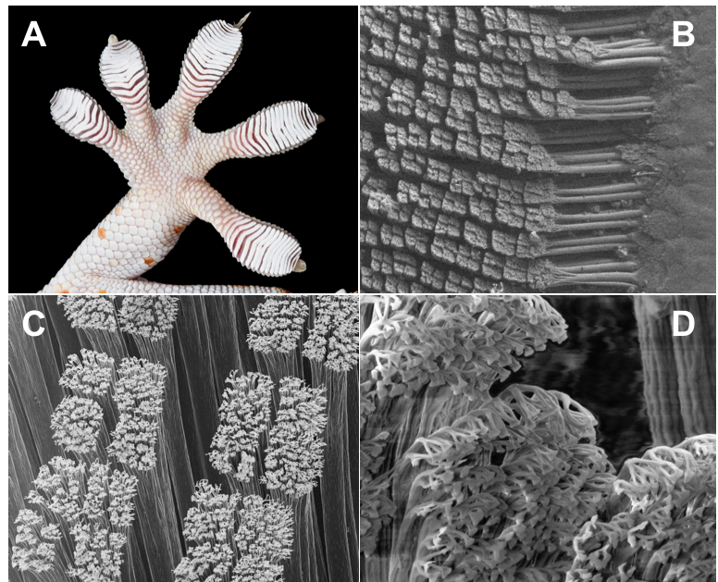
4th toe

Figure 4. Gecko toepads and lamellae. (A) Like anoles, geckos have lamellae. Taking a very close look at these can help us understand how they allow geckos and anoles to cling. (B) and (C) Millions of microscopic hairs, or setae, cover the lamellae. The setae are only as long as the width of two human hairs. (D) Each hair ends in up to 1000 even tinier tips, called spatulae. The spatulae tips are 200 billionths of a meter wide. Because of their small size they can interact with molecules on surfaces to create a clinging force. The individual forces between the molecules on the tips and the molecules on the surface are very tiny, but collectively, they create a force strong enough to hold up the entire animal. (Images by Kellar Autumn)
Figure 3. Scan of the right foot of a male A. carolinensis. To compare the number of lamellae (the special scales that look like ridges) on toepads of different lizards, scientists count the lamellae on the 4th toe, from the knuckle out to the end of the toepad. (Photo by Yoel Stuart)

MAKING A CLAIM

- In the table below, compare the range of perch heights of brown anoles with the range of perch height of green anoles that lived on islands without the brown anole. Do they overlap?

Perch height range brown anoles: _____________________

Perch height range green anoles on islands without the brown anole: _____________________

- Make a claim about how the native Green anole living on uninvaded islands will respond to an invasion by the Brown anole. Hint: Think about how an invasion might affect perch height and toepad size in the short-term (within the same generation) as well as in the long-term (over several generations).

Table 1. Data from lizards on 11 islands in Mosquito Lagoon collected 3 years (approx. 20 generations) after invasion. The data include perch height for both species, lamella number for green anoles, and whether or not an island has been invaded by the Brown Anole.
Island Name | Island INVADED by Brown Anoles? | GREEN ANOLE Average  Perch Height (cm) | BROWN ANOLE Average  Perch Height (cm) | GREEN ANOLE Average Lamella Number
Channel | Yes | 198 | 55 | 23.67
Crescent | No | 132 | N/A | 24.22
Hook | Yes | 185 | 86 | 24.11
Hornet | No | 92 | N/A | 23.15
Lizard | Yes | 173 | 100 | 24.27
North Twin | Yes | 173 | 77 | 24.31
Osprey | No | 106 | N/A | 23.70
Pine | No | 131 | N/A | 23.79
South Twin | No | 120 | N/A | 23.28
Yang | Yes | 158 | 56 | 24.41
Ying | Yes | 164 | 78 | 24.13

DATA ANALYSIS

- Calculate the mean (𝑥̅), standard deviation (s or SD), standard error (SE) and 95% confidence interval (95% CI) for the following measurements, and enter them in the table below.
FORMULAS
Mean
𝑥̅ = ∑𝑥_{i} / 𝑛
∑𝑥_{i} is the sum of all samples; 𝑛 is the number of samples

Standard Deviation
s = √(∑(𝑥_{𝑖}− 𝑥̅)² /(𝑛−1))

Standard Error
SE = s/√n

95% Confidence Interval
95% CI = 2 x SE
Upper limit: 𝑥̅ + (2 x SE); Lower limit: 𝑥̅ - (2 x SE)

  - Perch height of all Green anoles living on islands invaded by the brown anole.
  - Perch height of all Green anoles living on islands that were not invaded.
  - Number of lamellae on toepads of Green anoles living on invaded islands.
  - Number of lamellae on toepads of Green anoles living on islands that were not invaded.

GREEN ANOLE | PERCH HEIGHT |  | NUMBER OF LAMELLAE
GREEN ANOLE | Invaded islands | Uninvaded islands | Invaded Islands | Uninvaded Islands
Sample size (n)
Mean (𝑥̅)
Std. Deviation (s)
Std. Error (SE)
95% CI

- Construct two bar graphs using the spaces below or in an Excel or Google spreadsheet: one comparing mean perch height of Green anoles on invaded versus uninvaded islands, the other comparing mean lamellae number in Green anoles on invaded versus uninvaded islands. Remember to label all axes.

PERCH HEIGHT NUMBER OF LAMELLAE

- Compare the perch height and lamellae number of Green anoles on invaded and uninvaded islands.
  - What tendencies do you observe?
Perch height: _______________________________________________________________
Number of lamellae: _________________________________________________________
  - Can you determine whether any of the differences between Green anoles on invaded and uninvaded islands are statistically significant? Why or why not?

- In your plot, add the 95% confidence intervals as error bars around the mean. TIP: The top of the bar (or upper limit) equals 𝑥̅ + (2 x SE), and the bottom of the bar (or lower limit) equals 𝑥̅ - (2 x SE).

  - Can you now with more confidence determine whether any of the differences between invaded and uninvaded islands might be statistically significant? Why or why not?

- Now calculate the mean (𝑥̅), standard deviation (s or SD), and 95% confidence interval (95% CI) for the perch height of the Brown anole, and enter them in the table below.

- Using the space below or an Excel or Google spreadsheet, construct a bar graph comparing the mean perch height of Brown anoles with the mean perch height of Green anoles on invaded islands and of Green anoles on uninvaded islands. As above, add the 95% CIs as error bars and remember to label all axes.

PERCH HEIGHT
BROWN ANOLE | Perch Height
Sample size (n)
Mean (𝑥̅)
Std. Deviation (s)
Std. Error (SE)
95% CI

CONCLUSIONS

- Given your analysis above, what effect does the Brown anole have on the Green anole?

- Do the results support your claim? Explain your answer.

- Has this study demonstrated that negative interactions between two species (such as competition) can lead to…

  - …natural selection? Explain your answer.

  - …adaptation? Explain your answer.

  - …evolutionary change? Explain your answer.

  - …the evolution of a new Green anole species? Explain your answer.

authors
Yoel Stuart and Greg Clark, University of Texas, Austin, Tania Tasneem, Kealing Middle School
Revised for high school and undergraduate use by Sandra Blumenrath, HHMI, and Fred Wasserman, Boston University
Data provided by Yoel Stuart

