Activity for “Sleep Drives Metabolite Clearance from the Adult Brain”

Note to instructors:
This activity models the diffusion of cerebrospinal fluid (CSF) through the interstitial space in awake and sleeping brains. The activity involves observing the rate at which food coloring spreads from one end of a water-filled chamber to the other, while adding or removing obstacles to simulate the increase or decrease in cell volume which changes the volume of the interstitial space, as reported in the paper.

This activity can be done using a light-colored or clear waterproof chamber of any size bigger than several inches in each dimension. Any type of obstacles can be used (weighted glass jars, blocks of wood, etc) provided that they are fairly evenly spaced and that they occupy the appropriate volume of the chamber. Be sure to calculate the areas of the footprints of the obstacles you gather for the students. Cylindrical obstacles of equal diameter like jars, for example, cannot be packed sufficiently tightly to occupy enough of the chamber’s volume without nearly occluding water flow entirely. In general, supplying rectangular obstacles of a variety of sizes will make this activity as simple as possible. When designing obstacle layouts, pay close attention to the issue of tortuosity, discussed in section 12 of the activity.

Materials required:

- Waterproof chambers. A wide range of sizes is acceptable; this example uses a chamber of approximately 16.5” long, 7.5” wide, and 4” tall.

- Food coloring of at least three colors

- Water

- Timers or stopwatches

- Obstacles. These will be placed in the chamber, representing cells, to occupy varying fractions of its volume. Obstacles of any shape can be used, as long as they meet these conditions:

  - When set upright in the chamber, the obstacles should be of a uniform size from top to bottom. Cylinders like cans and jars meet this condition, but a cone or sphere would not, as they are narrower or wider at various heights.

  - Water can be added to the chamber only until the top of the shortest obstacle is reached; that is, none of the obstacles should be completely underwater. Therefore the obstacles used should be at least a few inches tall to allow the chamber to be sufficiently filled.

  - If non-rectangular obstacles are used, it will be necessary to provide some small obstacles to fill in space between the larger obstacles. Some obstacle shapes cannot pack tightly enough to simulate the highly compact interstitial volume observed in the brains of awake mice.

  - The obstacles must be large or dense enough to remain on the bottom of the chamber when water is added.

  - It must be possible for the students to calculate the footprint area of the obstacles.

Activity

In the paper by Xie et al., the authors explain how the glymphatic system washes away harmful metabolites more rapidly in sleeping or anesthetized mice than in awake mice. Interstitial fluid (ISF) flows through the brain in currents set up by the delivery of cerebrospinal fluid to the brain from channels set up along arteries, and removal of interstitial fluid through channels along veins. The authors observed these fluxes by labeling the fluid with dye and watching it wash into the brain. They found that the fluid penetrated more deeply and rapidly into the brain in sleeping and anesthetized mice than those of awake mice, suggesting that sleep improves metabolite clearance.

What biological changes could impede fluid from flowing into the awake brain? Imagine a small meadow in which one hundred stalks of bamboo are growing. When wind blows through the meadow, it flows quickly through the bamboo and carries away leaves, dust and insects. Similarly, fluid flows through the interstitial space between neurons to carry away proteins and metabolites secreted by the cells. Now imagine that instead of bamboo, one hundred large trees stand in the meadow. The outermost trees at the periphery of the forest still feel the force of the wind, but trees in the center will be shielded. The wind is unable to penetrate deeply into the group of trees, because there is relatively little space between the large tree trunks. Similarly, the authors provide evidence that the interstitial volume between brain cells becomes smaller during arousal, thus hindering the flow of interstitial fluid into the awake brain relative to the anesthetized or sleeping brain.

We can simulate the authors’ findings to get a sense for the changes that occur in the brain during sleep. The authors measure the diffusion of an ion (TMA+) through the brain to estimate the size of the interstitial space. On page 373, the authors report that in sleeping mice, the average interstitial volume fraction was 23.4%, while in awake mice, this fraction dropped to 14.1%. This indicates that in a given chunk of tissue from a sleeping mouse, 23.4% of the tissue volume is empty (interstitial space), while 76.6% is occupied by cells and accumulations of protein. A similar sample of tissue from an awake mouse would contain only 14.1% empty space, with 85.9% occupied. Complete the following activity to assess whether this change is likely to affect the flux of fluid through the interstitial space as dramatically as the authors report.

- First, consider the authors’ results: the volume of interstitial space drops from 23.4% in sleeping to 14.1% in awake mice. This may appear to be a small change – do you consider it likely that it could cause the large effect observed in the paper? One way to get a sense for the importance of a difference like this is to calculate the percentage change, using this formula:

  - Percent change = (V_{f}-V_{i})/V_{i} * 100, where V_{i} is the initial value and V_{f} is the final value of the measured parameter. This calculation describes how much a value changes as a percentage of the initial value, giving us a sense for how dramatic the change really is.

  - Perform this calculation using the volume of the interstitial space in sleeping mice as the initial value, and in awake mice as the final value. Do you think a change of this magnitude is likely to have consequences for the flow of fluid in the brain?

- To simulate this biological observation, we can observe the diffusion of food coloring through a chamber in the presence of varying amounts of obstacles. This is similar to the authors’ approach of labeling cerebrospinal fluid with a fluorescent dye, then observing its flow through the brain. Your task is to adapt your chamber and materials to resemble those described in this protocol. The example chamber will be 16.5 inches long and 7.5 inches wide.

- Measure your chamber and using tape, pencil, or pen markings, divide it into three compartments as illustrated below. The bulk of the chamber, labeled “TISSUE” in the center of the rectangle shown below, represents the brain tissue comprised of cells and interstitial space. Obstacles representing cells will be added to the TISSUE compartment. At either end of the chamber, leave a small compartment. One compartment, labeled “RESERVOIR,” represents the cisterna magna, the store of cerebrospinal fluid into which our dye will be loaded. The other compartment, labeled “ASSAY”, will be monitored throughout the experiment.

  - Your measurements will be of the time required for food coloring added to the RESERVOIR to appear in the ASSAY compartment. Calculate the area of the “footprint” of the TISSUE compartment. That is, measure the length and width of the TISSUE compartment, ignoring its height (because we use obstacles of uniform size at different heights, we can ignore volume and simply base our calculations on the area of the footprint of our compartments and obstacles).

  - Record the area of the TISSUE compartment, including units, here: _________________________

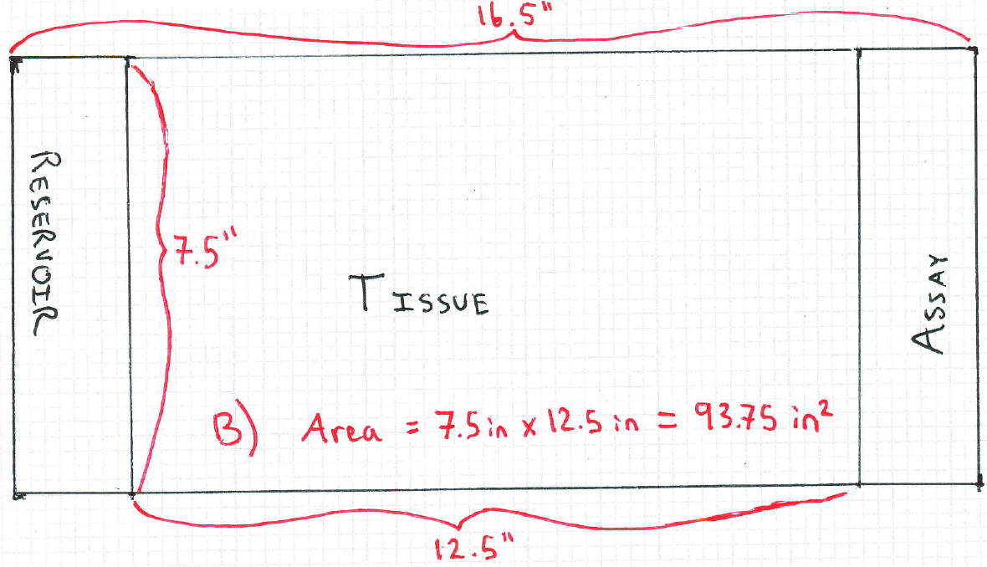

- To simulate the asleep and awake brains, you will use obstacles representing cells to occupy a certain percentage of the TISSUE compartment. The authors report the percentage of brain tissue that is empty in the two arousal conditions: the interstitial volume fraction. To determine how many obstacles, and of what size, should be added to the TISSUE compartment, you must calculate the total area of the footprint to be occupied by obstacles.

  - To do this, multiply the total area of the TISSUE compartment (found above in part B) by the fraction of tissue that the authors report is not empty (100% – the interstitial volume fraction) for each arousal condition. Record the results below.

  - Area of obstacles simulating asleep brain: ________________

  - Area of obstacles simulating awake brain: ________________

  - In which conditions do the simulated brains contain more obstacles? Does this make sense, considering the authors’ results?

- Gather enough obstacles to simulate each condition. As you collect obstacles, calculate the area of each obstacle’s footprint. Keep track of the sum of these areas until you have collected enough obstacles that their area equals your answer to the first part of C), above. Gather these obstacles into a group. They represent the cells in a sleeping brain. Placing these obstacles in the TISSUE compartment will cause the empty space in the compartment to be reduced to 23.4%, the size of the interstitial volume fraction reported in this paper.

Continue collecting obstacles and place them into a second group, until the running total of the area of all the obstacles you have collected (including both groups) equals your answer to the second part of C), above. The new obstacles in the second group represent the increase in obstacles that the authors observed in the awake brain. When added to the TISSUE compartment, they will decrease the amount of empty space to about 14.1%.

To measure the footprint area of a rectangular obstacle, multiply its length and width, ignoring height. To measure the footprint area of a cylindrical obstacle, find the radius of the circle on which the obstacle will rest. Then use the formula for the area of a circle (pi * radius^2) to find the footprint area of the obstacle. The footprint area of obstacles that rest on right-angle triangles can be calculated by measuring the base and height of the triangle (that is, the two sides adjacent to the right angle) then using the formula (1/2 * base * height). Obstacles of other shapes may be used after their footprint areas have been estimated.

- Place obstacles to simulate the sleeping brain. Arrange the first group of obstacles, representing cells in the asleep brain, throughout the TISSUE compartment. Ensure that space remains between them so you do not create walls. Take extra care that your obstacles do not form channels that will allow the food coloring to diffuse through some areas of the chamber but not others (see the note on tortuosity below). When all the obstacles have been added to the TISSUE compartment, gently add water to the chamber. Fill the chamber until the water level reaches the top of the shortest obstacle or the top of the chamber, whichever is shorter. Below is an example of an obstacle layout in which the obstacles representing the cells in a sleeping brain are drawn in black, while the additional obstacles representing cells in the awake brain are drawn in red.

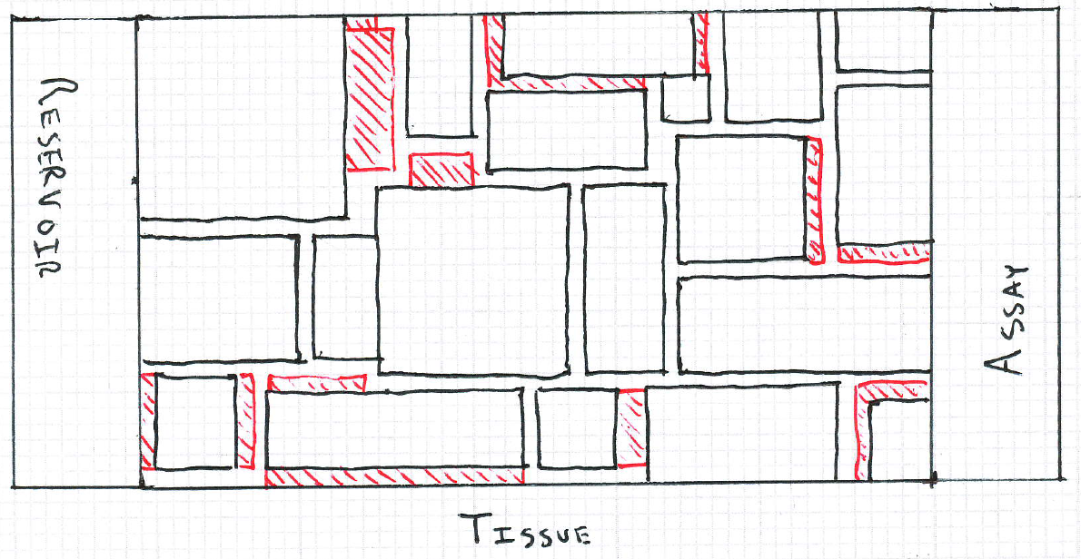

- To measure the rate of diffusion in this sleeping brain simulation, add several drops of food coloring to the RESERVOIR compartment and simultaneously begin timing the experiment. Observe the food coloring spread through the chamber, and record the time at which it appears in the ASSAY compartment. Repeat this experiment several times, recording the time elapsed each time. Your measurements will be most accurate if you can replace the water before each run, but if this is difficult different colors may be used for each repetition.

- Now simulate the awake brain. Drain the chamber and add the second group of obstacles, again taking care not to create walls or channels. It may be necessary to rearrange the previously added obstacles. By including both groups of obstacles, you have simulated the density of cells observed in the awake brain.

  - Are you surprised by how difficult it is to add the second group?

  - Is the decrease in space between the obstacles (cells) notable?

  - When the obstacles have been placed, refill the chamber with water and repeat the diffusion experiment as in part F). Record the elapsed time for several repetitions of the experiment.

- Analyze your results. Average your repetitions for the sleeping brain, and for the awake brain. Do you observe a difference; that is, is the diffusion time longer for one condition than for the other? Compare your findings with your classmates’.

- Think critically about the experiment. Based on the authors’ results, one would predict diffusion to occur faster under conditions simulating the sleeping brain (fewer obstacles) than the awake brain (more obstacles). What are some of the limitations of this simulation of the authors’ experiment, and why is it possible that our results could differ from theirs?

- What is the value of this sort of simulation? If the authors have discovered that the volume of interstitial space changes during sleep, why should we bother recreating the effect in a laboratory or classroom?

- Understand the role of tortuosity. The authors point out several times in the article that they observe a decrease in interstitial space with no change in tortuosity. Tortuosity refers to the degree to which a path has many twists and turns. When designing the layout of your obstacles, and particularly when adding extra obstacles to simulate the awake brain, it is crucial to not increase the “twistiness” of the paths through which your food coloring diffuses. The reason for this can be seen in the extreme example below. In this example, obstacles covering a relatively small fraction of the area of the TISSUE compartment are present, but they have been arranged to create a highly tortuous channel. Food coloring must travel along a very long path to reach the ASSAY compartment, resulting in the observation of a very slow rate of diffusion. Your challenge when placing the additional obstacles required to simulate the awake brain is to add them without increasing the tortuosity of the TISSUE compartment. The figure also illustrates the pitfall of creating walls which block off part of the chamber.

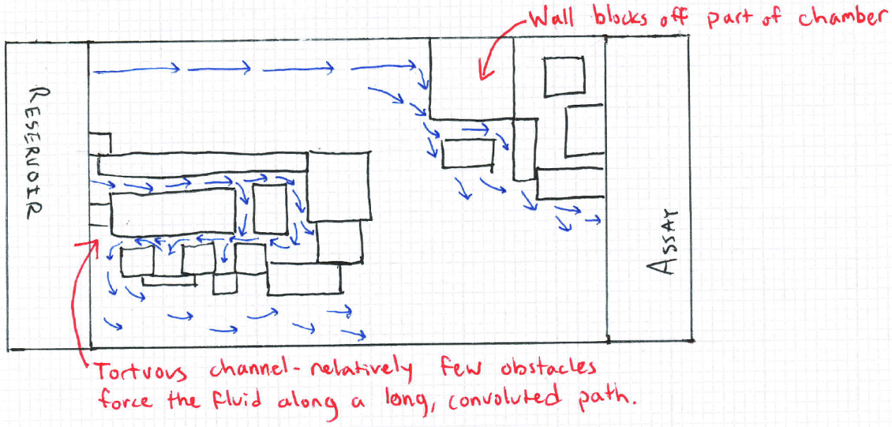

- You can reassure yourself of the importance of the principle of tortuosity by using some of the first group of obstacles, representing the cells in a sleeping brain, to create a highly tortuous path similar to the example below. Time the diffusion of food coloring from the RESERVOIR to the ASSAY compartment. You will notice a dramatic increase in the time required to observe food coloring in the ASSAY compartment, as compared to your recorded times when the obstacles were evenly distributed.

Answer Key

For Activity 1:
Percent change = (V_{f}-V_{i})/V_{i} * 100 = (14.1%-23.4%)/23.4% * 100 = (-9.3%)/23.4% * 100 = -0.397 * 100 = -39.7%. Yes, a decrease in the volume of interstitial space of nearly 40% is likely to be significant. This can be made clear with comparisons to more commonly observed changes: a 40% drop in the stock market would be unprecedented, and a 40% decrease in the average height in the US would put the average adult female at about 3’2” tall, with males at about 3’5” tall.

For Activity 3:
Verify that the students have accurately calculated the area of the TISSUE compartment by multiplying its length and width. The units should be given as the square of the measurement unit; for example, inches^2 or centimeters^2. In the example chamber, the TISSUE compartment is 12.5 inches long by 7.5 inches wide, for a footprint area of 93.75 inches^2.

For Activity 4:
Verify that the students have correctly completed both parts of the calculations. First, they must use the interstitial volume fraction to find the fraction of tissue that is not empty. They do this by subtracting the authors’ reported interstitial volume fraction values from 100%. Second, they must multiply these values by the total area of their TISSUE compartments. For the example chamber:

Example: (100% - interstitial volume fraction) * TISSUE compartment area = area of obstacles
Asleep: (100% - 23.4%) * 93.75 inches^2 = 71.8 inches^2
Awake: (100% - 14.1%) * 93.75 inches^2 = 80.5 inches^2

These calculations indicate that more obstacles are required to simulate the awake brain. This matches the authors’ finding that the interstitial volume fraction (that is, the empty or unoccupied space in brain tissue) is decreased in awake mice.

For Activity 5:
Verify that the students have gathered an appropriate set of obstacles. Using the asleep brain as an example, this means the students should gather a set of obstacles whose footprint areas sum to approximately 71.8 inches^2.

For Activity 6:
Check the students’ obstacle placement to verify that they do not create walls or channels (see the note on tortuosity).

For Activity 7:
Verify that the students record the time elapsed for at least three repetitions of the experiment.

For Activity 8:
The students should observe that it is surprisingly difficult to add the second group of obstacles without creating walls. This is the physical manifestation of the calculations performed in part A): even though the students must add a fairly small number of obstacles, they must fit them into an already compact interstitial space. Small changes in cell volume can have a large impact on the size of the interstitial space.

Verify that the students’ placement of the new obstacles do not create walls or channels (see the note on tortuosity) and verify that the students record the time elapsed for at least three repetitions of the experiment.

For Activity 9:
The students should average the three replicates for the awake condition, and the three replicates for the sleeping condition. They should observe slower diffusion in the condition simulating the awake brain; however, see the caveats listed below.

For Activity 10:
There are many limitations for this simulation. The most important is measurement error – the students are using only visual judgments to determine when the food coloring has reached the ASSAY compartment. Diffusion is slow and gradual, and therefore significant variability can be expected among students, and within each students’ replicates. The layout of obstacles within the TISSUE compartment is also crucial. If obstacles create walls or channels, the observed rate of diffusion will be dramatically affected.

Additionally, in our simulation food coloring is able to diffuse in three dimensions, but cannot flow over or under obstacles. Diffusion is therefore more restricted in our simulation than in the actual brain.

A subtler caveat is that our simulation involves food coloring diffusing around obstacles through relatively large spaces, likely at least a millimeter wide. Therefore, in our simulation, the molecules that are diffusing are many orders of magnitude smaller than the paths along which they diffuse. In the brain, the paths along which interstitial fluid diffuses are extraordinarily small. Large waste products, like proteins and metabolites, may be much closer in size to the spaces through which they pass between cells. Therefore, changes in interstitial volume may affect the diffusion of metabolites to a much greater extent than we observe in our simulation (imagine rolling basketballs or marbles through a room full of chairs. The basketballs would hit chair legs and bounce around, while the marbles, which are much smaller than the paths between chair legs, would on average travel much further through the room).

For Activity 11:
There are several reasons to perform simulations. Simulations can test whether it is truly plausible that a reported biological mechanism can explain a phenomenon. In this paper, the authors reported that the volume of the interstitial space changed during sleep and wakefulness, and that the rate of clearance of an injected metabolite was also changed during sleep and wakefulness. However, there is no easy way to directly change the volume of cells and observe whether metabolite clearance is affected – the authors could only attempt to influence both by manipulating arousal. With simulations, we can use physical laws and our own observations to test whether changes in cell volume like those reported in this paper are really sufficient to slow diffusion to the extent reported.

Another powerful reason to perform simulations is that they can reveal gaps in our knowledge. Suppose that we very precisely performed the experiment described in this protocol and found that diffusion slowed even further than reported in the paper. This would suggest that diffusion alone could not explain the authors’ results, and would guide future scientists to look for changes between sleeping and awake states that could explain the discrepancy.

