Discovering a genetic pathway

Activity for: Gametogenesis eliminates age-induced cellular
damage and resets life span in yeast.

**Recommended: complete this activity only after reading the above publication.**

Goals for this activity
- Analyze results of new experiments employing methods featured in Ünal et al

- From a list of genes, interpret evidence to decide which are likely to directly influence a phenotype

- Some genes work together and some oppose each other; determine these relationships and use them to build a genetic pathway

- Infer gene function from combined knowledge of phenotypes of mutants and subcellular localization of gene products

- Addressing and overcoming experimental limitations

Premise

A key finding from Unal et al. was that cellular events of sporulation that follow activation of the transcription factor Ndt80 are necessary to reset replicative life span. Moreover, artificially driving expression of Ndt80 in mitotic cells activates the same program.

Which genes are involved in life span resetting and what processes do they affect?

Ndt80 activates expression of many genes directly and inactivates some indirectly. We will determine the genes that function downstream of Ndt80 and build a genetic pathway for the genetic control of life span resetting.

Experiment 1: Further examination of Ndt80 target genes

Transcriptome profiling, which measures the abundance of all messenger RNAs in a sample, was performed on samples of cells passing synchronously through sporulation harvested just prior to and following activation of Ndt80. About 100 genes showed induced mRNA levels while another 100 showed reduced levels. You decide to determine the replicative life span (RLS) of yeast strains deleted for each of the top five up-regulated and down-regulated genes.

Top 5 down-regulated genes | Top 5 up-regulated genes
GENEA | GENEF
GENEB | GENEG
GENEC | GENEH
GENED | GENEI
GENEE | GENEJ

Interpret:

Genetic pathways can be deduced from genes whose activities correlate with a phenotype. Below, fill in those genes up or down-regulated by Ndt80 that affect life span according the RLS data from Activity Slide 1. Draw an arrow (↓) for genes activated or a blunted-arrow (⊥) for those inhibited by Ndt80. Similarly, indicate their influence (↓ for increased or ⊥ for decreased) on RLS relative to wild-type.

Regulator
(directs other genes)

Effectors
(carry out the dirty work)

Phenotype
(observable trait)
NDT80
Replicative life span

Thought questions:

What information have we left out of the genetic pathway above?

What are testable hypotheses one can generate given the pathway above?

If Ndt80 only promotes increased gene expression, how can you explain its effect on GENEB expression? What does that say about connections within a genetic pathway?

**Activity Slides 1 and 2: Results of life span experiments when the above genes are knocked out or overexpressed**

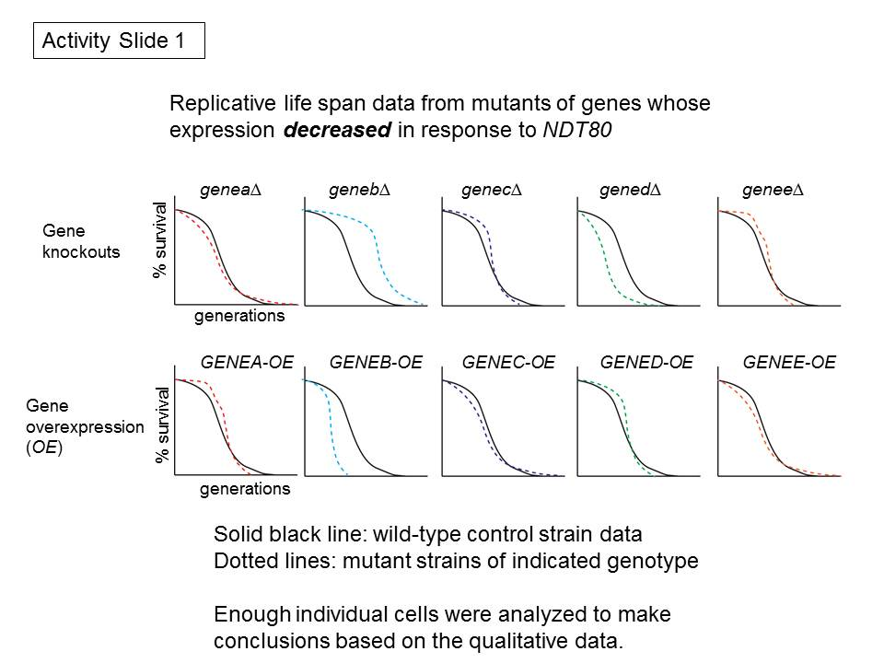

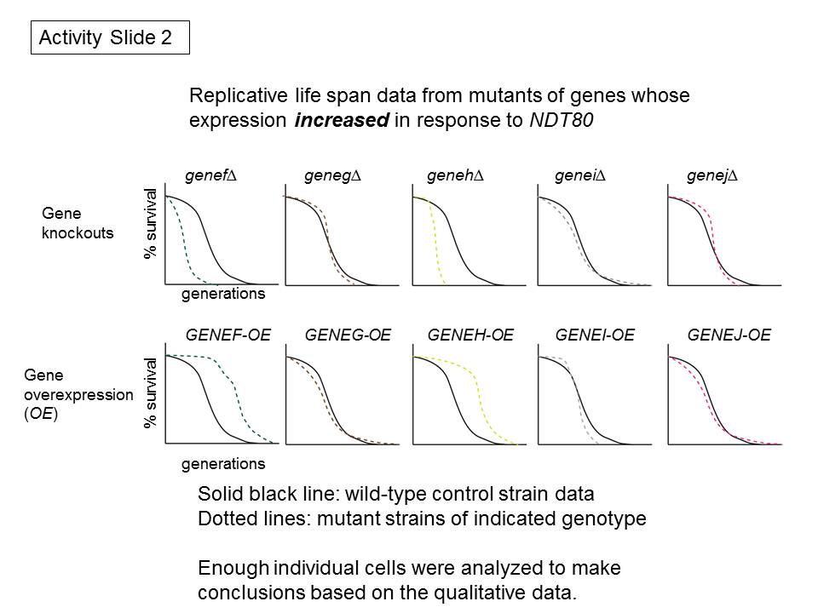

Experiment 2: Subcellular localization of target genes during Ndt80 expression.

To further understand the targets of Ndt80 important for life span regulation, you decide to create strains expressing a green fluorescent protein (GFP) tagged version of each gene. You observe the following for each GFP fusion protein before, during and after a transient expression of Ndt80 by fluorescence microscopy.

****Use Activity Slide 3 for microscopy images****

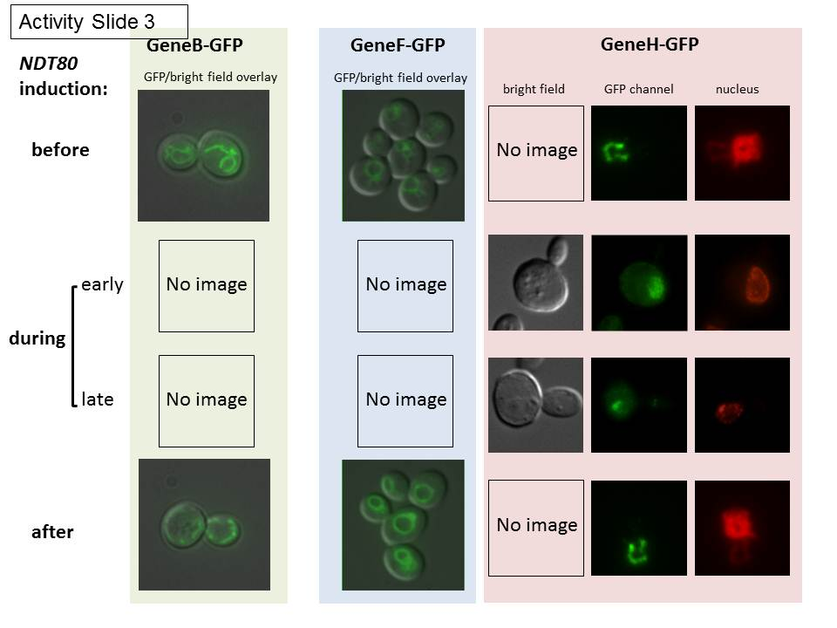

GeneB-GFP

Before: Localizes to filamentous structures in the cytoplasm (mitochondria) prior to induction.

During: Remains within cytoplasmic filamentous structures but decreases in GFP fluorescence.

After: Fluorescence intensity increases once again to pre-induction levels.

GeneF-GFP

Before: Fluorescence signal mainly on the membrane of a large semi-spherical cytoplasmic structure (vacuole).

During: Fluorescence intensity within the cytoplasmic structure increases dramatically at first then returns to previously observed levels even while Ndt80 is still being induced.

After: Identical fluorescence signal location and intensity as prior to Ndt80 induction.

GeneH-GFP

Before: Fluorescence signal in a cytoplasmic filamentous structure.

During: Early on, all fluorescence signal is now found within the nucleus in a crescent-moon shape. Later, the size of the crescent moon-like shape decreases by ~50% over the course of six hours.

After: GFP signal spreads over the entire nucleus, then becomes predominantly localized to filamentous structures within the cytoplasm.

Thought Questions:

The GFP-protein fusions examined either changed in abundance or localization in the course of NDT80 induction. Protein abundance or localization changes can occur as an undesirable consequence to the stress of sample preparation for microscopy. Describe a positive and negative control that could be used to determine if the change in abundance of GeneF-GFP was an artifact of sample preparation.

An experienced yeast biologist could tell you with confidence that GeneF-GFP localizes to the vacuolar membrane (the vacuole is similar to the lysosome) by analyzing the microscopy images. However, they could not tell you with confidence whether GeneB-GFP was within the mitochondrial matrix or on the cytoplasmic surface of the mitochondrial outer membrane. Considering the following facts, how can you explain their inability to establish a definitive localization of GeneB-GFP?

1. the diameter of a vacuole is roughly 1 micrometer

2. mitochondria are roughly cylindrical with a 1 micrometer length and 0.2 micrometer width

3. the diffraction limit (distance at which two light sources cannot be resolved) of light microscopes is 200 nm

Experiment 3: Determine the interaction of genes in the Ndt80 pathway

How important is each gene downstream of Ndt80 in mediating its effects on life span? Since a short interval of NDT80 overexpression extended the life span of mitotic cells outside the context of sporulation (Supplemental Figure S7C of Ünal et al) you decide to use this transient expression system followed by replicative life span analysis to further interrogate the pathway downstream of Ndt80.

The product of GeneB seems to shorten life span while the product of GeneH seems to promote longer life span. Which is more important in regulating life span: the increased activity of GeneH or the decreased activity of GeneB in response to NDT80? One can determine the relationship between genes and their effects on a phenotype by combining the two mutations in the same strain of cells.

****Activity Slide 4: The results of three experiments on GENEB and GENEH.****
Question being asked in each panel:

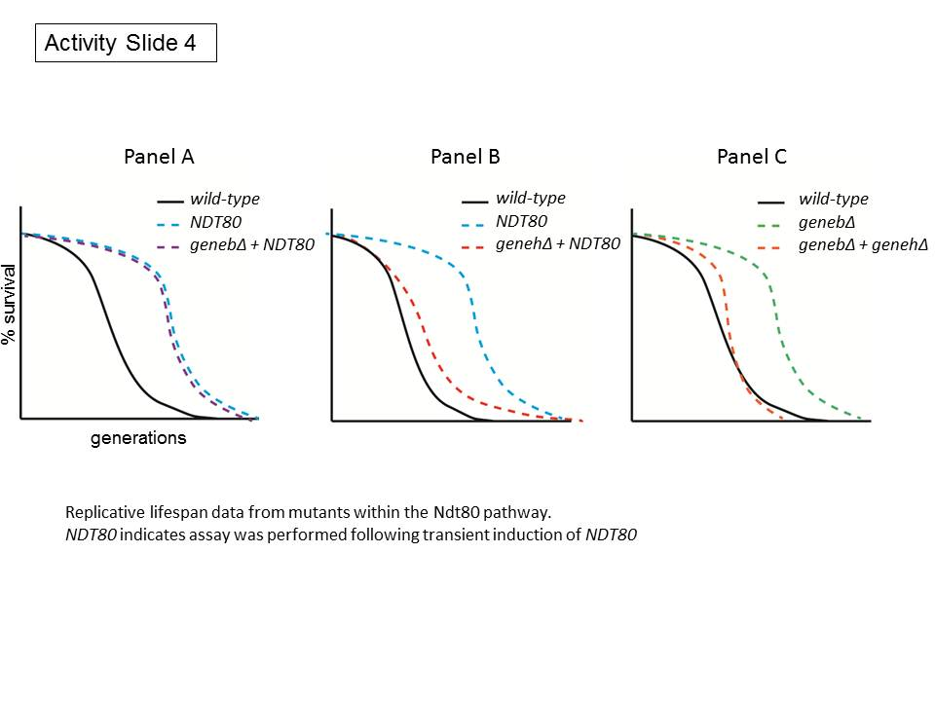

Panel A: Does geneb∆ further increase the RLS of cells that have induced NDT80?
Panel B: Is GENEH required for the RLS increase by NDT80 induction?
Panel C: Since geneb∆ is long-lived on its own (Activity Slide 1), does this require GENEH?

Thought Questions:

Does the data from Panel A suggest that the function of GeneB is necessary for life span extension in response to NDT80 induction?

What does the data from Panel B tell us about GeneH?

What does the data in Panel C tell us about the relationship between GENEB and GENEH?

Revise the Ndt80 pathway to incorporate the discoveries about GeneH and GeneB.

Phenotype
(observable trait)
Effectors
(carry out the dirty work)
Regulator
(directs other genes)
NDT80
Replicative life span

Construct a model for life span regulation by Ndt80 pathway genes

Multiple genes become up and down-regulated in response to NDT80 expression. By focusing on specific candidate genes, testing how mutants of these genes affect life span, and observing the abundance and localization of their products by microscopy, we can devise a model by which they modulate this phenotype. Assuming that one of the three forms of cellular damage examined in Ünal et al is limiting life span, incorporate the genetic and cell biological evidence from the three experiments into a model for Ndt80-dependent life span modulation. Speculate on not just the localization but also the possible functions of GeneB, GeneF and GeneH proteins.

